

If there is any technology that will change people’s life, work, and entertainment habits, that will be the Internet of Things (IoT).

Years earlier, if someone talked about IoT, there might be a portion of people who would not understand it. Nowadays, however, IoT has connected all equipment, no matter bracelets, home appliances, or robots, automobiles, and plants. According to a Forbes report, the number of networked devices will reach 11 billion by 2018, and that is exclusive of computers and mobile phones. Obviously, the topic of IoT will continue its heat for a long time.

Ruff, founded in 2014, came correctly with the good trend. Based on years’ sharp sense towards the industry, the then Ruff’s founding team had anticipated the market at the very early stage, and promptly started R&D to secure the first-mover advantage.

Several Ruff’s co-founders have their halos of outstanding achievements. Ruff CEO Roy Li is a serial entrepreneur, and former technical director of Nokia North America, being responsible for OVI open platform and Symbian operating system; CMO Jing Tianwei once served as investment director of LeBox Capital and participated in such projects as angel investments in EHANG and uSens Ince; chief architect Zhou Aimin was former business architect of Alipay, former platform architect of Shanda, and chief architect of Wandoujia, being granted special contribution award by Borland, and becoming the only Borland product expert in China that won such award. This also constitutes that Ruff will draw much attention since its establishment.

****The path from concept to implementation of IoT operating system****

At the very beginning, Ruff’s original intention was to provide software developers with an “Android” platform dedicated for IoT. First, it aimed to solve the problem of technical risk in the industry, and then they found that what really hinders IoT is a gap between software and hardware. Therefore, they shifted the focus towards operating system, being committed to solving the problem of IoT applications development and difficult access thereto.

One year later, Ruff OS IoT operating system that makes IoT applications easier was formally released, including three parts, namely SDK software tools development kit, software package sharing, and IoT development suite. In addition, the IoT operating system had also realized the first step to commercial implementation that year. For example, there was an energy enterprise turning to Ruff for IoT technical support, and the latter took advantage of its independently developed IoT gateway and underlying IoT operating system to provide the customer with a package of solutions for remote monitoring, operation, and maintenance of PV power stations.

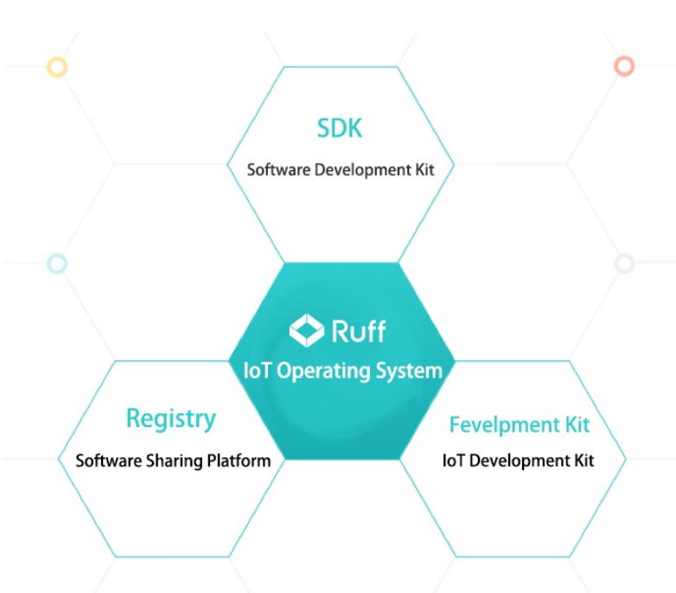

If 2016 was a “learning year” for Ruff OS IoT operating system to continue practice and improvement, then 2017 will be a crucial year for “commercial output”. The IoT OS has realized “Great Leap” in industrial sectors, and shifted its focus on helping traditional plants realize digital transformation.

Most traditional plants resemble a “black box”, and no one knows the production status of each equipment and each product, resulting in that the production plan cannot be finished on time, and low yield, and high labor costs, as well as grave losses in production incurred by unexpected halt of equipment. However, these pains will be overcome if traditional plants smoothly transform to digital modes.

During such transformation, Ruff has released Ruff Plant Insight, an IoT application for the industrial sector. As an APP, it has integrated underlying equipment data acquisition and access, data clouding and terminal scene visualization display, which can be flexibly configured to support multiple business scenarios, including equipment manufacturers, terminal factories, equipment leasing parties, service providers, etc., and provides such functions as remote management equipment, and real-time access to data and health status of devices, etc., making business implementation more concrete.

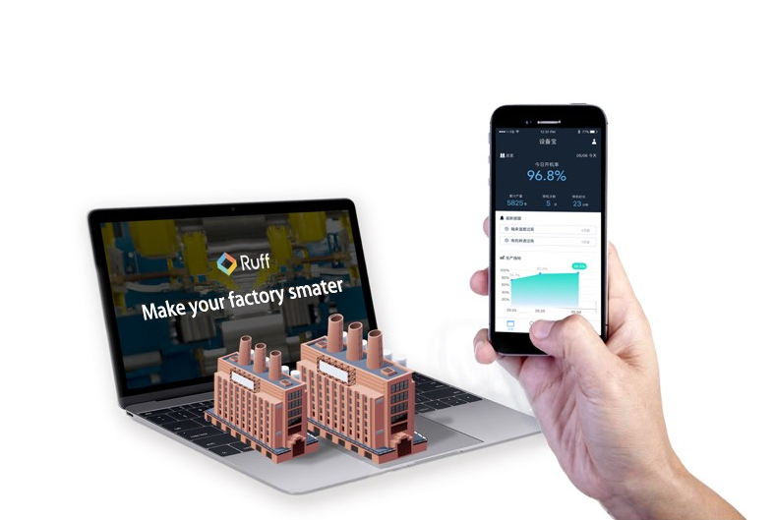

Ruff CEO Roy Li once said, “a company turning on 24 hours a day would produce five billion dollars a year, while an unexpected halt may cause a loss of tens of millions of dollars or even greater. Ruff helped a customer successfully intercept a halt as it was deployed in less than two weeks. But the annual fee we charged to the customer was very low, even less than 1% of the value we brought to it. ”

According to official data of Ruff, by the end of last December, Ruff Plant Insight had been launched in many industries, including wood-based panel factories, auto parts factories, textile factories, electronic factories and so on. It has become the productivity tool for dozens of manufacturers in the industrial era of IoT.

****Making Development on both Software and Hardware****

It is obvious that since the end of last year, Ruff’s ambitions have not been limited to software but extended to the hardware field. In the fourth quarter of 2017, Ruff launched the Intelligent Gateway to the IoT, with the three key advantages of compatibility (plug and play), scalability (software defines hardware) and maintainability (OOTB). The device has abundant hardware interfaces which can fit for the connections of a variety of devices. At the same time, as for the installation and configuration of the equipment, the operator can complete the configuration in only three steps, without the need of mastering any programming language.

But Ruff’s involvement in hardware field is not entirely due to ambition. The IoT can not be simply understood as connecting the hardware to the Internet in a communication mode and installing a broadband. In addition, the quality of each sensor and the ability of the hardware have to interact with the application ultimately .

Referring to the solutions of the most IoT projects that the hardware and software are separated, if a problem are met, the software team and hardware team should be found separately, and then work together to solve the problem on both sides. The efficiency of the solution is very low. And the feasibility is very low too. The implementation of software and hardware integration can make the fragmented hardware compatible and provide a unified interface to APP developers. Developers can only edit the existing API interface of the platform according to customer requirements and necessary business scenarios.

In the case of hardware, the developer can make compatibility with Ruff once to achieve calling Ruff driver package for every application, and improve the efficiency and the feasibility greatly. In addition, Ruff’s business range from software to hardware reflects that the technical strength of the company are fully reinforced in many aspects, and has the high scalability that cannot be underestimated .

****Ruff Chain testing the fusion capabilities of IOT and the block chain technology****

If you have heard about Ruff, you may know that, in addition to the above-mentioned software and hardware products, Raff has its own chain — Ruff Chain. From a theoretical point of view, the Ruff OS IOT operating system has been able to be compatible with most devices in the market. Then, is it still difficult to pass data on to the Ruff Chain? The answer is yes.

Although IOT has achieved the interconnection of things, it is composed of closed systems. For example, there is no interaction between the WAN and the LAN, and it is difficult to link the industrial system that is privatized and the IDC-based IT network, which is inconsistent with the requirements of IOT data on higher consistency and security. What Ruff Chain needs to solve is the problem of credible interoperability and paid interoperability between IOT devices of different systems, and to build an open big Ruff ecology.

PIC 3

Specifically, Ruff Chain is an architecture that combines IOT and the block chain. It contains a distributed operating system and an open main chain, so that it extends the peer-to-peer network in the virtual world and the consensus mechanism to offline, realizing the information flow driving the atomic flow and building up a new IOT ecology.

In this ecology, it uses DPoS as a consensus algorithm and will use the Ruff coin as the token for incentive, consumption and transaction in the Ruff public block chain ecosystem. Consumers will consume a certain amount of tokens in the course of property right or data transactions, and producers who provide the corresponding node resources and participate in verification, billing, etc. will receive Ruff coins for encouragement.

In fact, in addition to requiring the Ruff team members to have a large number of rich block chain technologies, the implementation of the Ruff public block chain further tests their capabilities to access IOT.

Since its birth, IOT has been fragmented, that is, there is no standard. For example, shared bicycles, intelligent electrical apparatus, smart home, etc., are all connected to a closed network. One way to solve this problem is to introduce operating systems that are compatible with a wide variety of hardware products and provide a unified programming interface.

At the same time, due to the fragmented nature of IOT, it is necessary to standardize the hardware, which is obviously more difficult. After all, the entire IOT industry has tried to solve this problem for more than two decades, without significant results achieved. In addition, the instructions of programming language are sometimes unreadable, and are easy to write bugs.

Therefore, without long-term industry experience and accumulation, it may be very difficult to solve the above problems, and we even have to learn and apply immediately. However, at that time, we may already be surpassed by our competitors. Fortunately, the opportunity is always reserved for people who are prepared. That is Ruff.

As we mentioned above, Ruff has developed the Ruff OS operating system since 2016, so it is able to solve the problem of fragmentation and standards of IOT. In addition, Ruff has access to numerous physical customers in several fields such as energy, agriculture and industry. Once such valuable data is put on the chain, it will further consolidate the first-mover status of Ruff.

At the same time, since it was established, Ruff has reached cooperation with many famous companies such as Microsoft China, Schneider, Baidu Cloud, and muRata, and has won several awards such as the Most Investment Value Award by the 2016 Microsoft Innovation Summit and the Best Innovation Award by 2017GE Predix Hackathon. What does that mean? This undoubtedly affirms the real technical force of Ruff, enhances the brand appeal of Ruff, and more importantly, contributes to the access capability of Ruff Chain to IOT. At this point, we believe that the construction of the Ruff public block chain ecology is just around the corner.

如果有什么技术可以改变人们的生活、工作和娱乐习惯，那就是物联网 (IoT)。

几年前，如果有人谈论物联网，可能会有一部分人不会理解它。然而，如今物联网已经连接了所有设备，无论是手环、家用电器，还是机器人、汽车和植物。根据福布斯的一份报告，到 2018 年，联网设备的数量将达到 110 亿台，这还不包括电脑和手机。显然，物联网的话题将持续很长时间。

Ruff 成立于 2014 年，顺应了好趋势。基于多年对行业的敏锐洞察力，当时的Ruff创始团队很早就预见到了市场，并迅速启动研发，以确保先发优势。

Ruff 的几位联合创始人都有着杰出成就的光环。Ruff CEO Roy Li 是一位连续创业者，曾任诺基亚北美技术总监，负责 OVI 开放平台和 Symbian 操作系统；CMO景天伟曾任乐盒资本投资总监，参与天使投资亿航、uSens Ince等项目；首席架构师周爱民曾任支付宝业务架构师、原盛大平台架构师、玩豆家首席架构师，获得Borland特殊贡献奖，成为国内唯一获得该奖项的Borland产品专家。这也构成了Ruff自成立以来就备受关注。

****物联网操作系统从概念到实现的路径****

最初，Ruff 的初衷是为软件开发者提供一个专门用于物联网的“Android”平台。首先，它旨在解决行业的技术风险问题，然后他们发现真正阻碍物联网的是软件和硬件之间的差距。因此，他们将重心转向操作系统，致力于解决物联网应用开发难接入的问题。

一年后，让物联网应用更简单的Ruff OS物联网操作系统正式发布，包括SDK软件工具开发包、软件包共享、物联网开发套件三部分。此外，物联网操作系统也在当年实现了商业化落地的第一步。例如，有一家能源企业向Ruff寻求物联网技术支持，后者利用其自主研发的物联网网关和底层物联网操作系统，为客户提供远程监控、运维一揽子解决方案。光伏电站。

如果说 2016 年是 Ruff OS 物联网操作系统继续实践和改进的“学习年”，那么 2017 年将是“商业输出”的关键一年。IoT OS实现了工业领域的“大跃进”，重心转向帮助传统工厂实现数字化转型。

传统工厂大多像一个“黑匣子”，没有人知道每一台设备、每一件产品的生产状态，导致生产计划无法按时完成，产量低，人工成本高，亏损严重因设备意外停机而导致生产。但是，如果传统工厂顺利向数字化模式转型，这些痛苦将迎刃而解。

在这样的转型过程中，Ruff 发布了 Ruff Plant Insight，这是一款面向工业领域的物联网应用程序。作为一款APP，集成了底层设备数据采集接入、数据上云和终端场景可视化展示，可灵活配置支持多种业务场景，包括设备制造商、终端工厂、设备租赁方、服务商等，并提供远程管理设备、实时获取设备数据和健康状态等功能，使业务实施更加具体。

Ruff CEO Roy Li 曾说过：“一家一天 24 小时不间断运转的公司，一年会产生 50 亿美元的收入，而意外停机可能会造成数千万美元甚至更多的损失。Ruff 帮助客户成功拦截了停机，因为它在不到两周的时间内部署完毕。但是我们向客户收取的年费非常低，甚至不到我们给它带来的价值的1%。”

据Ruff官方数据，截至去年12月底，Ruff Plant Insight已经在多个行业上线，包括人造板厂、汽车配件厂、纺织厂、电子厂等。它已成为物联网工业时代数十家制造商的生产力工具。

****在软件和硬件上进行开发****

很显然，从去年年底开始，Ruff 的野心并没有局限于软件，而是延伸到了硬件领域。2017年第四季度，Ruff推出了物联网智能网关，具有兼容性（即插即用）、可扩展性（软件定义硬件）和可维护性（OOTB）三大关键优势。该设备具有丰富的硬件接口，可以适应多种设备的连接。同时，对于设备的安装和配置，操作人员只需三步即可完成配置，无需掌握任何编程语言。

但Ruff涉足硬件领域并不完全是出于野心。物联网不能简单理解为将硬件以通信方式连接到互联网，安装宽带。此外，每个传感器的质量和硬件的能力最终都必须与应用程序交互。

参考大多数物联网项目软硬件分离的解决方案，如果遇到问题，应该分别找到软件团队和硬件团队，然后共同解决双方的问题。解决方案的效率非常低。而且可行性也很低。软硬件一体化的实现，可以让碎片化的硬件兼容，为APP开发者提供统一的接口。开发者只能根据客户需求和必要的业务场景，对平台已有的API接口进行编辑。

在硬件方面，开发者可以一次性兼容Ruff，实现对每个应用程序调用Ruff驱动包，大大提高效率和可行性。此外，Ruff从软件到硬件的业务范围都体现了公司在多方面的技术实力得到了充分的加强，并且具有不可低估的高扩展性。

****Ruff Chain 测试物联网与区块链技术的融合能力****

如果你听说过 Ruff，你可能知道，除了上述软硬件产品，Raff 还有自己的链——Ruff Chain。从理论上讲，Ruff OS IOT操作系统已经能够兼容市面上大部分设备。那么，将数据传递到 Ruff Chain 上是否仍然困难？答案是肯定的。

IOT虽然实现了物联网，但它是由封闭系统组成的。例如，广域网和局域网之间没有交互，私有化的工业系统和基于IDC的IT网络难以链接，不符合物联网数据对更高一致性和安全性的要求。Ruff Chain需要解决的是不同系统的物联网设备之间的可信互通和付费互通问题，构建开放的大Ruff生态。

图 3

具体来说，Ruff Chain 是一种结合物联网和区块链的架构。它包含分布式操作系统和开放的主链，从而将虚拟世界中的点对点网络和共识机制延伸到线下，实现信息流驱动原子流，构建物联网新生态。

在这个生态中，它使用 DPoS 作为共识算法，将使用 Ruff 币作为代币，在 Ruff 公有区块链生态系统中进行激励、消费和交易。消费者在产权或数据交易过程中会消耗一定数量的代币，提供相应节点资源并参与验证、计费等的生产者将获得Ruff币作为激励。

事实上，除了要求 Ruff 团队成员拥有大量丰富的区块链技术外，Ruff 公链的落地更进一步考验了他们接入物联网的能力。

IOT从诞生之日起就是碎片化的，也就是没有标准。比如共享单车、智能电器、智能家居等，都接入了一个封闭的网络。解决这个问题的一种方法是引入与各种硬件产品兼容并提供统一编程接口的操作系统。

同时，由于物联网的碎片化特性，需要对硬件进行标准化，这显然难度更大。毕竟，整个物联网行业为了解决这个问题已经尝试了二十多年，也没有取得显著成果。另外，编程语言的指令有时不可读，容易写bug。

因此，如果没有长期的行业经验和积累，可能很难解决上述问题，甚至要立即学习和应用。但是，那个时候，我们可能已经被我们的竞争对手超越了。幸运的是，机会总是留给有准备的人。那是拉夫。

正如我们上面提到的，Ruff 从 2016 年开始开发 Ruff OS 操作系统，因此能够解决 IOT 的碎片化和标准问题。此外，Ruff 在能源、农业和工业等多个领域拥有众多实体客户。一旦这样有价值的数据上链，将进一步巩固Ruff的先发地位。

同时，自成立以来，Ruff与微软中国、施耐德、百度云、muRata等多家知名企业达成合作，并荣获2016微软创新峰会最具投资价值奖、 2017GE Predix Hackathon 最佳创新奖。那是什么意思？这无疑肯定了Ruff真正的技术力量，提升了Ruff的品牌号召力，更重要的是，有助于Ruff Chain对IOT的接入能力。至此，我们认为Ruff公有区块链生态的建设指日可待。